CHAPTER ONE

INTRODUCTION

BACKGROUND OF THE STUDY
This study draws inspiration from the continuously evolving field of cloud computing and the application of hybrid cryptography. Cloud computing is a data storage and computing technique that enables users to access a wide range of computing resources—such as storage, processing power, and applications—over the internet. The term cloud refers to multiple data centers that provide these resources to users (Mell & Grance, 2011). Cloud services can be limited to a single organization, known as enterprise clouds, or extended to multiple organizations, referred to as public clouds (Mell & Grance, 2011). Hosting web applications on the cloud is also a form of cloud computing, and this approach will be implemented in this project (Armbrust et al., 2010).
However, storing files in the cloud requires a high level of security to prevent unauthorized access, data breaches, and data manipulation. This need for security leads to the application of hybrid cryptography (Katz & Lindell, 2014).
Cryptography is the practice of protecting information by transforming it into coded formats, ensuring that only authorized users can access the original data (Stallings, 2017). It uses rule-based algorithms to encrypt and decrypt data. The main goals of cryptography include:
- Confidentiality
- Integrity
- Non-repudiation
- Authentication
To achieve these we use either of the symmetric key algorithms or the asymmetric key algorithm.
Hybrid cryptography is the merger of multiple encryption algorithms so as to benefit from the strengths of each algorithms. It is a secure encryption method as song a s both the public and private keys are fully secure.

STATEMENT TO THE PROBLEM
This study seeks to merge the hybrid cryptography algorithm with files stored on the cloud systems. We want to create a system that would store files in form of text, images, audio and video.
Taking security seriously is the main theme of this project. The files stored would be stored and encrypted to as to preserve the security and then can only be retrieved with the use of the decryption key.

1.3 AIMS OF THE STUDY

The aims of this study include:
- Creating a functioning web application capable of storing files and encrypting them in a cloud database.
- Test the web application using a cloud service for its hosting and the data storage.
- Deploy the web application and come up with strategies to improve it.

1.3 OBJECTIVES OF THE STUDY
The objectives of the study include:
- Examining previous studies in the field of hybrid cryptography and cloud computing.
- Studying in detail he various encryption techniques.
- Figuring out a system that can effectively store, encrypt and decrypt data using the encryption keys.

1.4 SIGNIFICANCE OF THE STUDY
This study brings out the academic and theoretical aspect of data encryption and confidentiality into a real life working software. This project would result in the building of a software that can be further used for research purposed for the function of improvement in data security.
The project is organized such that; Chapter One gives a brief introduction in form of the Background of the Study of a general overview of the concept of cloud computing and the filed of cryptography and more specifically a hybrid implementation of algorithms. In Chapter Two, we have a broad look at the related implementations of hybrid cryptography systems. Chapter Three examines the System Architecture, the system design and analysis. Chapter Four presents the implementation of the project using necessary programming languages and development models. It also presents the result of testing carried out. Chapter Five rounds off the project work with the summary, conclusions and recommendations for future works.

1.5 SCOPE OF THE STUDY
The scope of the study would be contained and limited to relatively smaller file formats like texts, images, some small sized audio and videos. The reason for these limits placed on them is to ensure that the small cloud space budgeted is not exhausted in the course of testing and deployment. Large cloud space for storage also correlates with a large fee for the cloud service. The implementation of this idea and project was done with the user of the server-side programming language PHP and the MySQL database querying language. These languages were chosen for their server-side compatibility, their high level of security and for the general web compatibility. The front-end technologies used include HTML, CSS and JavaScript. This will also be hosted as a web application on an online domain.

1.6 DEFINITION OF TERMS
- CLOUD: "The cloud" refers to servers that are accessed over the Internet, and the software and databases that run on those servers.
- CRYPTOGRAPHY: Cryptography refers to secure information and communication techniques derived from mathematical concepts and a set of rule-based calculations called algorithms, to transform messages in ways that are hard to decipher.
- ENCRYPTION: Data encryption translates data into another form, or code, so that only people with access to a secret key (formally called a decryption key) or password can read it. Encrypted data is commonly referred to as cipher text, while non encrypted data is called plain text.
- SYMMETRIC ENCRYPTION: Symmetric encryption which is also known as symmetric key cryptography uses one single key to encrypt and decrypt data. You have to share this key with the recipient in order for that recipient to interpret the data.
- ASYMMETRIC ENCRYPTION: Asymmetric encryption uses two distinct, yet related, keys. One key, the Public Key, is used for encryption, and the other, the Private Key, is for decryption. As implied in the name, the Private Key is intended to be private so that only the authenticated recipient can decrypt the message.
- Symmetric encryption is a method of securing information where the same secret key is used for both encryption and decryption. This means the sender and the receiver must both have access to the same key in order to securely communicate. The sender uses this shared key to convert readable data, known as plaintext, into unreadable data called ciphertext, and the receiver uses the same key to convert the ciphertext back into its original readable form. Because only one key is involved, symmetric encryption is generally fast and efficient, making it suitable for encrypting large amounts of data with minimal computing power. Common examples of symmetric encryption algorithms include AES (Advanced Encryption Standard), which is widely used today, as well as older methods like DES and 3DES, and others such as Blowfish, though some of these are now considered less secure. A simple way to understand symmetric encryption is to think of a padlock that both people open using the same key—anyone who has that key can access what is locked.
- HYBRID ENCRYPTION: Hybrid encryption is a mode of encryption that merges two or more encryption systems. It incorporates a combination of asymmetric and symmetric encryption to benefit from the strengths of each form of encryption. These strengths are respectively defined as speed and security.
Hybrid encryption is a security technique that combines symmetric encryption and asymmetric encryption in a single system in order to take advantage of the strengths of both methods. In hybrid encryption, a random symmetric key, often called a session key, is first generated. This key is used to encrypt the actual data or message because symmetric encryption algorithms such as AES are very fast and efficient, especially when handling large amounts of data. However, instead of sharing this symmetric key directly, which would be insecure, the key is encrypted using asymmetric encryption. The sender encrypts the symmetric key with the receiver’s public key using algorithms such as RSA or Elliptic Curve Cryptography. Both the encrypted data and the encrypted symmetric key are then sent to the receiver. Upon receiving the message, the receiver uses their private key to decrypt the symmetric key, and once the symmetric key is recovered, it is used to decrypt the original data. This approach makes hybrid encryption both secure and efficient because asymmetric encryption safely handles key exchange while symmetric encryption ensures fast data processing.
- PUBLIC KEY: This is a cryptographic key that can be obtained and used by anyone to encrypt messages intended for a particular recipient, such that the encrypted messages can be deciphered only by using a second key(the private key) that is known only to the recipient
- PRIVATE KEY: A private key, also known as a secret key, is a variable in cryptography that is used with an algorithm to encrypt and decrypt code. Private keys are only shared with the key’s generator, making it highly secure.
A private key in computing is a secret piece of information used in cryptography to secure data and verify identity. It is a long, randomly generated value that is kept confidential by its owner and works together with a public key. When data is encrypted using a public key, only the corresponding private key can decrypt it, ensuring that only the intended recipient can access the information. Private keys are also used to create digital signatures, which prove that data was sent by a specific person or system and has not been altered. In systems like secure logins, HTTPS, and cryptocurrency wallets, possession of the private key represents ownership and control, which is why keeping it safe and never sharing it is extremely important.

CHAPTER 2
LIETRATURE REVIEW
2.1 OVERVIEW OF THE STUDY AREA
Cloud computing refers to the delivery of computing services such as storage, applications, processing power, and networking over the internet. It enables users to access applications as utilities without the need for local installation, thereby supporting mobility, scalability, and collaboration. Cloud services are delivered over public and private networks and support applications such as email services, web conferencing, customer relationship management systems, and online data storage.
Cloud computing allows organizations to dynamically scale resources based on demand, ensuring optimal utilization of computing infrastructure. This flexibility has transformed traditional IT models by reducing capital expenditure on hardware and shifting costs to a pay-as-you-use model. As a result, cloud computing has become a foundational technology for modern digital transformation initiatives.
The cloud environment supports platform independence, enabling users to access services from various devices such as desktops, laptops, tablets, and mobile phones. This independence enhances collaboration and supports remote work, making cloud computing essential in today’s globally connected business environment.
Despite these advantages, cloud computing introduces several technical and organizational challenges. Since data and infrastructure are managed by third-party cloud service providers, concerns related to data confidentiality, privacy, availability, and regulatory compliance have intensified. Issues such as vendor lock-in, insecure data deletion, isolation failure in multi-tenant environments, and compromised management interfaces pose serious risks to users.
To address these concerns, security mechanisms are integrated into cloud computing systems, with cryptography being one of the most critical components. Cryptographic techniques ensure that data stored in the cloud or transmitted over networks remains confidential and tamper-proof. Consequently, the study of cloud computing cannot be separated from the study of cryptographic systems, as both work together to provide secure, reliable, and trustworthy cloud services.
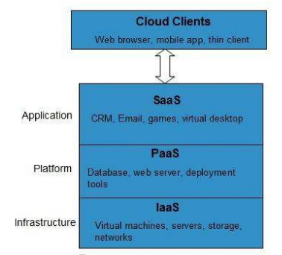

2.2 THEORETICAL FRAMEWORK
The theoretical framework of this study provides the foundational concepts and models that explain how cloud computing operates and how cryptographic systems are used to secure cloud environments. It integrates cloud computing architecture with information security theories, emphasizing confidentiality, integrity, and availability (CIA triad) as core security objectives.
This framework explains the relationship between cloud deployment models, service models, and cryptographic mechanisms, showing how security controls are applied at different layers of the cloud computing stack.
2.2.1 Cloud Computing Models
Cloud computing models define how cloud services are structured, delivered, and accessed by users. These models are categorized into deployment models and service models.
a. Deployment Models
Deployment models describe the ownership, access level, and operational control of cloud infrastructure. Each model presents unique security implications and use cases.
- Public Cloud:
In the public cloud model, computing resources are owned and managed by third-party cloud service providers and delivered over the public internet. This model offers high scalability, cost efficiency, and ease of access. However, due to shared infrastructure and multi-tenancy, public clouds face increased security and privacy risks, making cryptographic protection essential for sensitive data.
- Private Cloud:
A private cloud is dedicated to a single organization and can be hosted either on-premises or by a third-party provider. It offers greater control, customization, and security compared to public clouds. Organizations handling sensitive or regulated data often prefer private clouds, where cryptographic policies and access controls can be strictly enforced.
- Community Cloud:
The community cloud model is shared among multiple organizations with similar requirements, such as regulatory compliance or security needs. It enables cost sharing while maintaining a higher level of trust than public clouds. Cryptographic mechanisms are used to ensure secure data sharing and isolation among participating organizations.
- Hybrid Cloud:
The hybrid cloud combines two or more cloud models, typically public and private clouds, allowing data and applications to move between them. This model supports flexibility and optimized resource utilization. Security in hybrid clouds is complex, requiring consistent cryptographic standards across environments to protect data during transfer and storage.
b. Service Models
Service models define the level of abstraction at which cloud services are provided. Each model shifts responsibility between the cloud service provider and the user.
- Infrastructure as a Service (IaaS):
IaaS provides fundamental computing resources such as virtual machines, storage, and networking. Users have control over operating systems and applications, while the provider manages the underlying infrastructure. Security at this level relies heavily on encryption of virtual storage, secure networking protocols, and access control mechanisms.
- Platform as a Service (PaaS):
PaaS offers development platforms, runtime environments, and deployment tools. It abstracts infrastructure management, allowing developers to focus on application logic. Cryptography in PaaS is applied to secure application data, APIs, and development pipelines.
- Software as a Service (SaaS):
SaaS delivers complete software applications over the internet. Users interact with applications through web browsers without managing infrastructure or platforms. Security responsibilities largely fall on the provider, making encryption of user data, authentication, and secure access mechanisms critical.
- Anything as a Service (XaaS):
XaaS extends cloud service offerings to include Network-as-a-Service, Database-as-a-Service, Identity-as-a-Service, and other specialized services. These services rely on cryptographic techniques to secure identities, transactions, and communications.
2.2.2 Cryptographic Systems
Cryptographic systems form the core security mechanism in cloud computing by protecting data against unauthorized access and modification. They ensure that data remains confidential and trustworthy, even when stored or processed on shared infrastructure.
Components of a Cryptosystem
- Plaintext: The original, readable data that requires protection.
- Encryption Algorithm: A mathematical procedure that transforms plaintext into unreadable ciphertext using an encryption key.
- Ciphertext: The encrypted data that is transmitted or stored in the cloud.
- Decryption Algorithm: A reverse process that converts ciphertext back into plaintext.
- Encryption Key: A secret or public value used during encryption.
- Decryption Key: A corresponding value used to retrieve the original data.
Types of Cryptosystems
- Symmetric Key Encryption:
Symmetric encryption uses a single shared key for both encryption and decryption. It is computationally efficient and suitable for encrypting large volumes of cloud data. However, secure key distribution and trust between communicating parties remain significant challenges.
- Asymmetric Key Encryption:
Asymmetric encryption uses a pair of mathematically related keys: a public key and a private key. It eliminates the need for pre-shared secret keys and is widely used for secure key exchange and authentication in cloud systems. Due to higher computational requirements, it is often combined with symmetric encryption in practical cloud security implementations.
Public Key Infrastructure (PKI)
Public Key Infrastructure provides a trusted framework for managing public keys and digital certificates. PKI ensures the authenticity of public keys through trusted certificate authorities, enabling secure communication, authentication, and trust establishment in cloud environments.
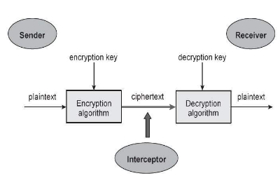

2.3 RELATED WORKS
Zevini Sabo and Ismaila (2023) proposed a secure cloud file storage system using a hybrid cryptographic approach that combines Elliptic Curve Cryptography (ECC) with the ChaCha20 symmetric encryption algorithm. Their work focused on reducing computational overhead while maintaining strong security for cloud-stored files. Experimental results showed improved performance compared to traditional RSA-based systems.
Saginayev et al. (2022) developed a hybrid cloud security framework that integrates AES-256 for data encryption, RSA for secure key exchange, and SHA-256 for data integrity verification. The study emphasized confidentiality and integrity of files stored in cloud environments and demonstrated that hybrid cryptography enhances security without significantly increasing processing time.
Dalave et al. (2021) presented a secure file storage model using a combination of AES, DES, and RC6 algorithms alongside steganography techniques. Their approach focused on hiding encrypted data within images before uploading it to the cloud, thereby providing an additional layer of protection against unauthorized access.
Wani and Kumar (2020) designed a hybrid cryptographic system for cloud file storage that employs AES and 3DES for encryption and RC6 for improved performance. Their research demonstrated that combining multiple encryption techniques increases resistance to brute-force and cryptanalytic attacks.
Bizi and Oladipo (2023) proposed a secure cloud storage architecture using AES for data encryption, RSA for key management, and Twofish to further strengthen data protection. Their work evaluated system performance and showed that hybrid cryptography improves confidentiality and reliability in cloud storage environments.
Satheesh Kumar et al. (2022) implemented a hybrid cryptographic file storage system deployed on Amazon Web Services (AWS). The model combined symmetric encryption with asymmetric key exchange and incorporated steganography to conceal encrypted files, thereby enhancing data confidentiality on public cloud platforms.
Holla and Cholli (2019) conducted a comprehensive study on file security using hybrid cryptography in cloud computing. Their work reviewed various combinations of symmetric and asymmetric algorithms and highlighted the effectiveness of hybrid encryption in addressing major cloud security challenges.
Chaudhari and Bhaladhare (2021) presented a survey on hybrid cryptography techniques for secure file storage in the cloud. The study analyzed several encryption combinations, particularly AES and RSA, and concluded that hybrid cryptography provides better security and performance compared to single-algorithm approaches.
Bhawane and Ahuja (2020) proposed a secured cloud data storage system using hybrid cryptography by combining symmetric encryption for data confidentiality and asymmetric encryption for secure key distribution. Their system focused on preventing unauthorized access and improving trust in cloud services.
Kumari and Malhotra (2019) designed a hybrid encryption model that integrates Blowfish with RSA to secure cloud-stored data. Their research demonstrated improved encryption speed and reduced key management complexity when compared to traditional encryption techniques.
Kurian et al. (2021) implemented a secure file storage mechanism using AES for encrypting data files and RSA for encrypting the AES keys. Their system ensured secure storage and retrieval of files while maintaining data confidentiality in cloud computing environments.
Lai and Heng (2022) proposed a secure cloud file storage framework that integrates AES, ElGamal encryption, SHA-2 hashing, and two-factor authentication. The system enhanced data confidentiality, integrity, and user authentication, making it suitable for sensitive cloud applications.
Bizi and Oladipo (2022) conducted a case study on hybrid cryptographic cloud storage, evaluating performance metrics such as encryption time and storage efficiency. Their findings showed that hybrid cryptographic systems outperform single-algorithm models in both security and scalability.
An IJSAT research study (2021) introduced a hybrid cryptographic model using AES, RSA, and adaptive key management techniques. The system dynamically generated encryption keys to enhance security and reduce vulnerability to key compromise in cloud storage systems.
An IJRPR study (2023) presented a secure file storage solution using AES for data encryption and RSA for key exchange. The research focused on improving encryption efficiency while maintaining strong data protection in cloud environments.
Solomon et al. (2020) proposed a triple-phase hybrid security model for cloud storage that combines AES encryption, secure key management, and steganography. Their approach enhanced confidentiality by encrypting and concealing data before uploading it to the cloud.
Bertrand et al. (2024) developed a hybrid encryption-based cloud storage system that integrates AES and RSA. The study emphasized secure data sharing and access control, showing that hybrid encryption improves cloud data confidentiality and trust.
Shivaramakrishna and Nagaratna (2023) proposed a novel hybrid cryptographic framework that combines AES with One-Time Passwords (OTP) and RSA. Their system enhanced authentication and encryption, making it suitable for highly sensitive cloud storage applications.
S. Kumar (2022) presented a hybrid AES-ECC cryptographic model for securing cloud storage data. The study demonstrated that ECC provides strong security with smaller key sizes, thereby reducing computational overhead compared to RSA-based systems.
Fujisaki and Okamoto(2020) introduced a hybrid encryption transformation that combines public-key and symmetric-key encryption. This foundational work laid the theoretical basis for modern hybrid cryptographic systems widely used in secure cloud storage.
Douceur et al. (2022) proposed convergent encryption, a technique that enables encrypted data deduplication in cloud storage systems. Although focused on storage efficiency, the concept is relevant to secure cloud file storage architectures.
Song, Wagner, and Perrig (2021) introduced searchable symmetric encryption, allowing encrypted cloud data to be searched without decryption. This concept supports secure and functional cloud storage systems.
A recent quantum-classical hybrid encryption study proposed combining quantum key distribution with AES encryption to provide future-ready security for cloud file storage.
Another study on functional encryption and privacy-preserving analytics explored hybrid cryptographic techniques that protect cloud-stored data while enabling controlled access and secure data processing.
Bairwa et al. (2023) proposed a hybrid cryptographic technique for secure data sharing in cloud environments using hashing and visual cryptography. Their approach enhanced data confidentiality and protected cloud-stored files from unauthorized access.

Zevini Sabo & Ismaila | 2023 |  | Low computational cost with strong security. | Limited real-world cloud testing.
  Secure File Storage on Cloud Using Hybrid Cryptography
Saginayev et al. | 2022 |  | Ensures confidentiality and integrity. | High computational overhead due to RSA.
  Secure File Storage on Cloud Using Hybrid Cryptography
Dalave et al. | 2021 |  | Extra security using steganography. | Increased system complexity
  Secure the File Storage on Cloud Computing Using Hybrid Cryptography Algorithm
Wani & Kumar | 2020 |  | Strong resistance to attacks. | High encryption time.
  Secure File Storage on Cloud Using a Hybrid Cryptography Algorithm
Kurian et al. | 2021 |  | Simple and effective hybrid design. | Poor scalability support.
  Secure File Storage in Cloud Using Hybrid Encryption
Lai & Heng | 2022 |  | Enhanced security with 2FA. | Authentication overhead.
  Secure File Storage on Cloud Using Hybrid Cryptography
Shivaramakrishna & Nagaratna | 2023 |  | Improved authentication and encryption. | OTP management challenges.
  A Novel Hybrid Cryptographic Framework for Secure Data Storage in Cloud

2.5 GAP ANALYSIS AND JUSTIFICATION OF THE STUDY
A review of existing literature shows that hybrid cryptographic techniques are widely used to secure file storage in cloud computing environments. Most of the reviewed studies combine symmetric encryption algorithms such as AES, Blowfish, RC6, or ChaCha20 with asymmetric algorithms like RSA, ECC, or ElGamal to ensure data confidentiality and secure key exchange. While these approaches have significantly improved cloud data security, several critical gaps remain, which justify the need for further research in this area.
One major gap identified is that many existing systems focus predominantly on data confidentiality, with limited consideration for efficient key management, access control, and scalability in multi-user cloud environments. In several studies, encryption keys are managed statically or centrally, increasing the risk of key compromise and reducing system flexibility.
Another important gap is the overdependence on RSA-based asymmetric encryption. Although RSA is secure, it introduces high computational overhead and longer encryption time, especially when handling large files or operating in resource-constrained environments. Only a few studies explored lightweight alternatives such as ECC, and those that did often lacked detailed performance evaluation or practical deployment.
Additionally, many of the reviewed works were assessed using theoretical analysis or limited simulations, with little emphasis on real-world cloud implementation. This limits the applicability of such systems in practical cloud storage scenarios, where performance, scalability, and storage overhead are critical factors.
Some studies attempted to enhance security through multiple encryption layers or steganography, but these approaches often increase system complexity and processing time, making them less suitable for real-time or large-scale cloud applications. There is also limited effort toward achieving an optimal balance between strong security and system efficiency.
Furthermore, most existing solutions do not provide a unified end-to-end security framework that integrates encryption, secure key exchange, user authentication, and controlled file access into a single system. This fragmented approach leaves cloud storage systems vulnerable to security loopholes and implementation inefficiencies.
These identified gaps clearly justify the need for this study. With the increasing adoption of cloud storage services and the growing risk of data breaches, there is a strong demand for a secure, efficient, and scalable cloud file storage solution. This study is therefore justified in its aim to design and implement an improved hybrid cryptographic system that addresses the limitations of existing works.
Specifically, this study is justified because it seeks to:
- Develop an optimized hybrid cryptographic framework that ensures strong data confidentiality while reducing computational overhead.
- Improve key management and access control mechanisms to support secure multi-user cloud environments.
- Reduce reliance on computationally expensive algorithms by integrating more efficient asymmetric encryption techniques where applicable.
- Provide practical implementation and performance evaluation on a cloud or cloud-like platform.
- Achieve a balance between security, efficiency, and usability in cloud file storage systems.
- Offer a unified end-to-end security model covering encryption, key exchange, authentication, and secure file access.
In summary, this study is necessary to bridge the gap between existing theoretical hybrid cryptographic models and practical, efficient, and secure cloud file storage systems. The outcomes of this research will contribute to the advancement of secure cloud storage technologies and provide a reliable solution for protecting sensitive data in cloud environments.

2.5 CONCEPTUAL FRAMEWORK
The conceptual framework presents a structured representation of the key variables in this study and illustrates the relationships between cloud computing environments, associated security risks, and cryptographic systems used to mitigate those risks. It serves as a bridge between the theoretical foundations of cloud computing and the practical security challenges addressed in this research.
This framework is built on the premise that as organizations increasingly adopt cloud computing models, they are exposed to various security threats. The effective application of cryptographic systems acts as an intervening mechanism that enhances data protection and trust in cloud services.
A. Cloud Computing Environment (Independent Variables)
The cloud computing environment represents the independent variables of the study. These variables define how cloud services are deployed and delivered to users.
- Deployment Models
  - Public Cloud
  - Private Cloud
  - Community Cloud
  - Hybrid Cloud
These deployment models determine the level of control, accessibility, and exposure to security risks. For example, public clouds offer broad accessibility but higher security exposure, while private clouds provide greater control and security.
- Service Models
  - Infrastructure as a Service (IaaS)
  - Platform as a Service (PaaS)
  - Software as a Service (SaaS)
  - Anything as a Service (XaaS)
Service models influence responsibility sharing between cloud service providers and users. Each layer introduces distinct security requirements that must be addressed through appropriate protection mechanisms.
B. Cloud Security Risks (Moderating Variables)
Cloud security risks act as moderating variables that affect the relationship between cloud computing adoption and secure service delivery. These risks arise due to shared infrastructure, third-party management, and remote access.
- Data breaches and unauthorized access
- Privacy violations
- Vendor lock-in
- Isolation failure in multi-tenant environments
- Management interface compromise
- Insecure or incomplete data deletion
These risks can negatively impact data confidentiality, integrity, and availability if not properly managed.
C. Cryptographic Systems (Intervening Variables)
Cryptographic systems serve as intervening variables that mitigate cloud security risks. They provide technical mechanisms to secure data throughout its lifecycle—during storage, processing, and transmission.
- Symmetric Key Encryption
  - Ensures fast and efficient data encryption for large datasets
  - Suitable for data-at-rest and bulk data encryption in cloud storage
- Asymmetric Key Encryption
  - Enables secure key exchange and authentication
  - Used in secure communication channels and identity verification
- Public Key Infrastructure (PKI)
  - Provides trust management through digital certificates
  - Ensures authenticity of users and cloud service providers
The integration of these cryptographic mechanisms strengthens cloud security by addressing confidentiality, integrity, authentication, and non-repudiation.
D. Secure Cloud Outcomes (Dependent Variables)
The dependent variables represent the expected outcomes of effectively applying cryptographic systems within cloud computing environments.
- Secure data storage and transmission
- Enhanced data confidentiality and integrity
- Improved user trust in cloud services
- Reduced security breaches and data loss
- Compliance with regulatory and organizational security requirements
E. Relationship Among Variables
The conceptual framework illustrates that cloud computing adoption (independent variables) introduces security risks (moderating variables). Cryptographic systems (intervening variables) are applied to manage and reduce these risks, leading to secure and reliable cloud computing outcomes (dependent variables).
This framework guides the study by clarifying how cryptographic systems can be strategically implemented across different cloud models to enhance security, support trust, and promote the safe adoption of cloud computing technologies.

CHAPTER THREE

METHODOLOGY

This chapter presents the Agile methodology used in the iterative design and development of the proposed secure file storage system. It outlines how each phase (analysis, design, implementation, testing) was approached incrementally and adaptively. The chapter describes the Agile practices, artifacts, and modelling techniques used to ensure a functional, efficient, and secure system through continuous feedback and improvement.
3.1 Choice of Methodology
The project adopts an Agile (Scrum) development methodology instead of a linear Waterfall model. Agile is an iterative, incremental approach where requirements and solutions evolve through collaboration and frequent evaluation. This approach was chosen because the requirements for a secure cloud storage system often change as new security issues are discovered during development. Agile’s flexibility allows the team to incorporate feedback quickly and adjust priorities on the fly, which is particularly valuable when dealing with complex security requirements. In Agile Scrum, the project is broken into short sprints (timeboxed iterations, typically 2–4 weeks each). The team (which in this case may consist of the student developer and an advisor acting as stakeholder) maintains a Product Backlog of features, security requirements, and tasks. At the start of each sprint, the team conducts a Sprint Planning meeting to select a set of backlog items to implement and to define clear acceptance criteria for them. The team then works collaboratively during the sprint to design, code, and test those items. For example, in one sprint the team might focus on implementing user registration and authentication; in the next sprint, on file encryption and decryption. Each feature is coded and tested within the sprint, and a working increment of the system is delivered at the end. Regular daily stand-up meetings (even if informal) help the team stay aligned, discuss progress, and address any impediments. After each sprint, a Sprint Review (demo) is held to show the working features to the stakeholder, gather feedback, and update the backlog. A Retrospective is conducted to reflect on what went well and what could improve, further refining the process for the next sprint. This iterative approach ensures that security measures (such as encryption, key management, and access control) are validated early and continuously. For instance, encryption routines are developed and unit-tested in early sprints, and any discovered vulnerabilities can be fixed in subsequent iterations. In contrast to a single big integration at the end (as in Waterfall), Agile promotes continuous integration and testing. This reduces the risk of last-minute security flaws.

3.2 Location of the Study
The study was conducted within an academic and computing environment where file storage systems are commonly used. This location provided a suitable environment for studying existing systems and understanding user needs. In such an environment, there is access to both practical and theoretical resources, including computer laboratories, internet facilities, and academic materials.
The controlled environment also made it possible to test the proposed system under realistic conditions. The study environment allowed the researcher to interact with users, observe their behaviors, and understand the challenges they face with existing file storage systems. The availability of internet resources also facilitated access to technical documentation, research papers, and online tutorials needed for the development of the system.

3.3 Method of Data Collection
Data collection for this study was conducted through secondary sources. Secondary data collection involves obtaining information that has already been documented. This approach is suitable for academic research as it provides a broad base of existing knowledge and reduces the time required for primary data collection.
The data collection process involved reviewing textbooks on system analysis, database design, and software engineering. Academic journals and conference papers on secure file storage systems were also studied. These sources provided insights into current practices, encryption techniques, authentication methods, and access control mechanisms. Existing research projects on file storage systems were examined to learn from their strengths and weaknesses. Additionally, online technical documentation related to PHP, MySQL, and encryption algorithms was studied to guide the implementation of the system.
By using secondary data, the researcher was able to build a strong theoretical foundation for the proposed system and apply best practices in system design and development.

3.4 Sampling Techniques
The study employed a purposive sampling technique. Purposive sampling is a non-probability sampling method where the researcher selects sources based on their relevance to the study. In this case, literature and systems related to secure file storage, authentication, encryption, and access control were selected. The purpose of using purposive sampling was to focus on information that directly contributes to the development of a secure file storage system.
The sampling process involved selecting research papers, textbooks, and case studies that provide valuable insights into file storage security. Sources that were not relevant to the study were excluded. This ensured that the research remained focused and relevant. The purposive sampling technique was effective in identifying information that was directly applicable to the system’s requirements and design.

3.5 Analysis of the Existing System
The existing personalized file storage system was analyzed to understand its operational flow and limitations. The system allows users to register, log in, upload files, retrieve files, and exit the system. While the system performs basic file storage functions, it lacks robust security features and proper access control.
During analysis, the researcher examined how users interact with the system, how data is stored and retrieved, and how the system responds to user requests. The analysis also involved studying the system’s architecture, database structure, and authentication mechanism. It was observed that the existing system does not employ strong encryption or multi-factor authentication. The database is also not structured to provide adequate security, and administrative controls are limited.
This analysis provided the basis for identifying the requirements for the new system. It helped to determine the improvements needed to enhance security, usability, and efficiency.
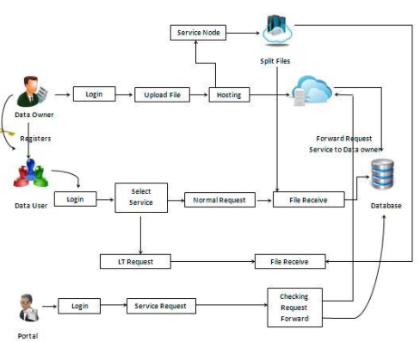
Source: Tanebaum,A.S, and Van Steen, M. (2016)
Figure 3.1: Existing system
3.6 Weaknesses of the Existing System
The analysis of the existing system revealed several weaknesses. The authentication mechanism is weak, relying only on simple username and password combinations. Such a mechanism is vulnerable to brute force attacks, password guessing, and credential theft. Additionally, the system lacks proper password policies such as minimum length, complexity requirements, and password expiration. This increases the risk of unauthorized access.
Another significant weakness is the absence of strong encryption. Files are stored in plain text or basic formats, making them vulnerable to unauthorized access and data breaches. Without encryption, sensitive information can be accessed by attackers who gain access to the database or server. Furthermore, the system lacks role-based access control, meaning that unauthorized users may access files that do not belong to them.
The existing system also lacks administrative monitoring. There is no mechanism to track user activities, log file access, or detect suspicious behavior. This makes it difficult to identify security breaches or unauthorized access. Overall, the existing system is vulnerable to data theft and lacks the necessary security features required for protecting sensitive information.

3.7 Proposing a New System
To address the weaknesses of the existing system, a new secure file storage system is proposed. The proposed system is designed to provide enhanced security, improved access control, and better data management. The system introduces secure user registration using OTP verification, which ensures that only legitimate users can create accounts.
The proposed system also incorporates encryption and decryption mechanisms. Files uploaded by users are encrypted before storage, ensuring confidentiality. Only authenticated users with valid decryption keys can access their files. This prevents unauthorized access even if the database is compromised.
Role-based access control is another feature of the proposed system. Users can only access their own files, while administrators have privileges to manage users and monitor system activities. The system also includes administrative functions such as blocking suspicious users, deleting user accounts, and managing system settings. Overall, the proposed system aims to provide a secure and reliable file storage solution.
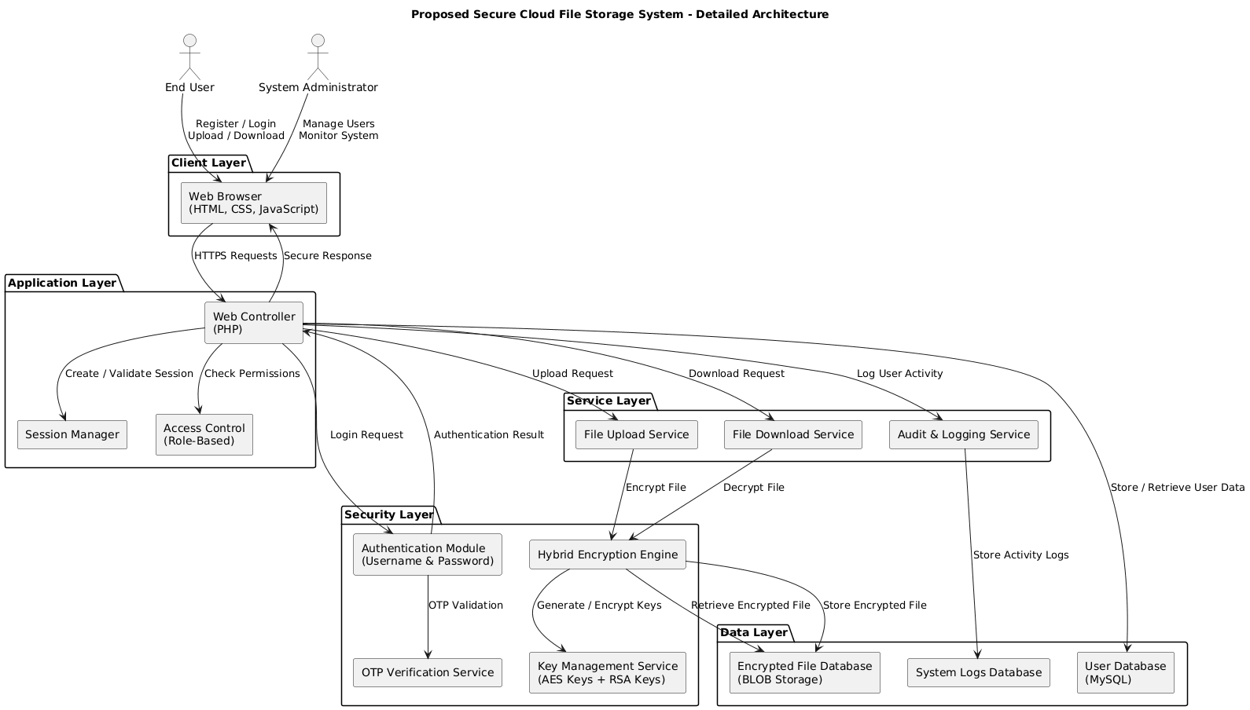
Figure 3.2: Proposed System

3.8 Analysis of the Proposed System
The proposed system is analyzed to ensure that it meets the required security and performance standards. The system is designed to provide confidentiality, integrity, and availability of user data. It is based on a modular architecture that separates the user interface, application logic, security module, and database.
The proposed system improves the existing system by implementing strong authentication, encryption, and access control mechanisms. It ensures that user data is protected from unauthorized access and data breaches. The system also enhances usability by providing a user-friendly interface and efficient file management. Additionally, the system is designed to be scalable, allowing for future expansion and the addition of new features.

Table 3.1: User Table
S/NO | NAME | DATA TYPE | DESCRIPTION
1 | UserID | Varchar | Primary key for Customer identification
2 | Password | Varchar | Security for Customer
3 | First_Name | Varchar | GENERAL IDENTIFICATION OF THE USER
4 | Last_Name | Varchar | GENERAL IDENTIFICATION OF THE USER
5 | Email Address | Varchar | GENERAL IDENTIFICATION OF THE USER
6 | Username | Varchar
7 | Password | Varchar

Table 3.2 Admin table
S/NO | NAME | DATA TYPE | DESCRIPTION
1 | UserID | Varchar | Primary key for Customer identification
2 | Username | Varchar
3 | Password | Varchar

Table 3.3 File table
S/NO | NAME | DATA TYPE | DESCRIPTION
1 | UserID | Varchar | Primary key for Customer identification
2 | File name | BLOB | The File in the database

3.9 High-Level Model of the Proposed System
The high-level model provides a general overview of the proposed system architecture and shows how the major components interact. The model consists of the user interface, application logic, security module, and database layer.
The user interacts with the system through a web interface. User requests are processed by the application logic, which communicates with the security module to validate user credentials and perform encryption/decryption. The database stores user information and encrypted files. The system uses secure communication between the layers to ensure data integrity and confidentiality.
The high-level model provides a clear understanding of how data flows within the system and how different components interact to achieve secure file storage.

3.10 System Design
3.10.1 Overview of the Design
System design is the phase where requirements are translated into a detailed blueprint for implementation. The proposed system is designed using a modular approach, which divides the system into independent modules that perform specific functions. This approach improves maintainability, scalability, and reusability of the system.
The design also focuses on security. Encryption and decryption mechanisms are integrated into the system to ensure confidentiality of stored files. User authentication is strengthened using OTP verification and secure password policies. The system also incorporates role-based access control to ensure that users can only access their own files.
Additionally, the system design emphasizes user-friendliness. The user interface is designed to be intuitive and easy to navigate. Users can easily register, log in, upload files, and download files without requiring technical knowledge.
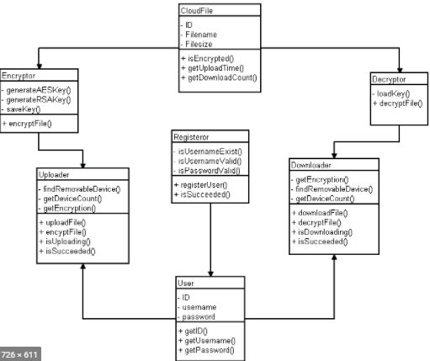
Figure 3.3: Overview of the design
3.10.2 Inputs to the Design
The inputs to the system design include user registration data, login credentials, uploaded files, encryption keys, and administrative commands. Each input is validated to ensure correctness and prevent security breaches.
User registration data includes the user’s name, email, username, and password. The system validates the data to ensure uniqueness and accuracy. Login credentials are validated against stored data in the database. Uploaded files are validated to ensure they are in acceptable formats and sizes. Encryption keys are generated securely and used to encrypt and decrypt files. Administrative commands are validated and executed with proper access control to prevent unauthorized system modifications.
These inputs form the basis for system processing and determine how the system responds to user actions.

3.10.3 Component Design
Component design describes the internal structure and interaction of system modules. The system consists of the following components:
User Component: This component handles user registration, login, file upload, and download. It interacts with the security module to validate user credentials and encryption keys. The user component also communicates with the database to store and retrieve data.
Admin Component: This component allows the administrator to manage users, block suspicious accounts, and monitor system activities. It ensures system integrity and security by enforcing access control policies.
Security Component: This component performs OTP verification, encryption, and decryption. It ensures secure storage of files and prevents unauthorized access. The security component also generates encryption keys and manages their storage.
Database Component: This component stores user information, administrator data, and encrypted files. It uses MySQL to provide efficient storage and retrieval. The database is designed to support data integrity and security.

3.10.4 State Design
State design represents the different states of the system and the transitions between them. The system can exist in various states such as idle, registration, login, upload, download, and logout.
In the idle state, the system awaits user interaction. When a user begins registration, the system transitions to the registration state where user details are collected and verified. After successful registration, the system transitions to the login state where user credentials are authenticated. Once authenticated, the system moves to the logged-in state, allowing users to upload or download files. After completing tasks, users can log out, transitioning the system back to the idle state.
The state design helps to model system behavior and ensures smooth transitions between different states.

3.11 Data Design
3.11.1 Conceptual Data Design
Conceptual data design identifies key entities and relationships without specifying implementation details. Entities represent real-world objects in the system. In this project, the main entities are User, Admin, and File. Relationships define how entities interact. For example, a user can upload multiple files, while an admin can manage multiple users. This level of design provides a clear understanding of the system’s data structure.

3.11.2 Logical Data Design
Logical data design converts conceptual entities into structured tables. The user table stores user details such as user ID, username, password, and email. The admin table stores administrator details. The file table stores file metadata and encrypted file data. Keys and constraints are defined to ensure data integrity and prevent redundancy. The logical design provides a blueprint for database implementation.

3.11.3 Physical Data Design
Physical data design specifies how data will be stored in the database. MySQL is used for implementation. The physical design defines data types, primary keys, foreign keys, and indexes. It also specifies storage formats for files, such as using BLOB for encrypted file data. The physical design ensures efficient storage and retrieval of data.

3.12 User Interface Design
The user interface is designed to be simple, intuitive, and user-friendly. It consists of registration, login, file upload, file download, and admin dashboard screens. Each screen is designed with clear navigation and validation to prevent errors. The interface uses HTML, CSS, and JavaScript to provide responsive and interactive user experiences.
The registration page includes form validation and OTP verification. The login page ensures secure authentication. The file upload page allows users to select files, upload them, and view progress. The file download page lists uploaded files and provides secure download options. The admin dashboard provides tools for managing users and monitoring system activity.

3.13 UML Diagrams
3.13.1 Use Case Diagram
The use case diagram illustrates the interactions between actors and system functions. It shows how users and administrators perform tasks such as registration, login, file upload, and user management. The diagram helps to visualize system requirements and interactions.
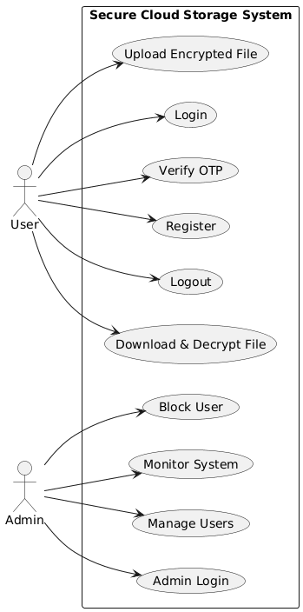
Figure 3.4: Use Case Diagram
3.13.2 Class Diagram
The class diagram represents the structure of the system by showing classes, attributes, methods, and relationships. It helps to model system objects and their interactions. The class diagram is essential for object-oriented design and implementation.

3.13.3 Flowchart
The flowchart shows the operational flow of the system. It illustrates the sequence of actions performed by users and the system. The flowchart helps to understand the system logic and identify potential issues.

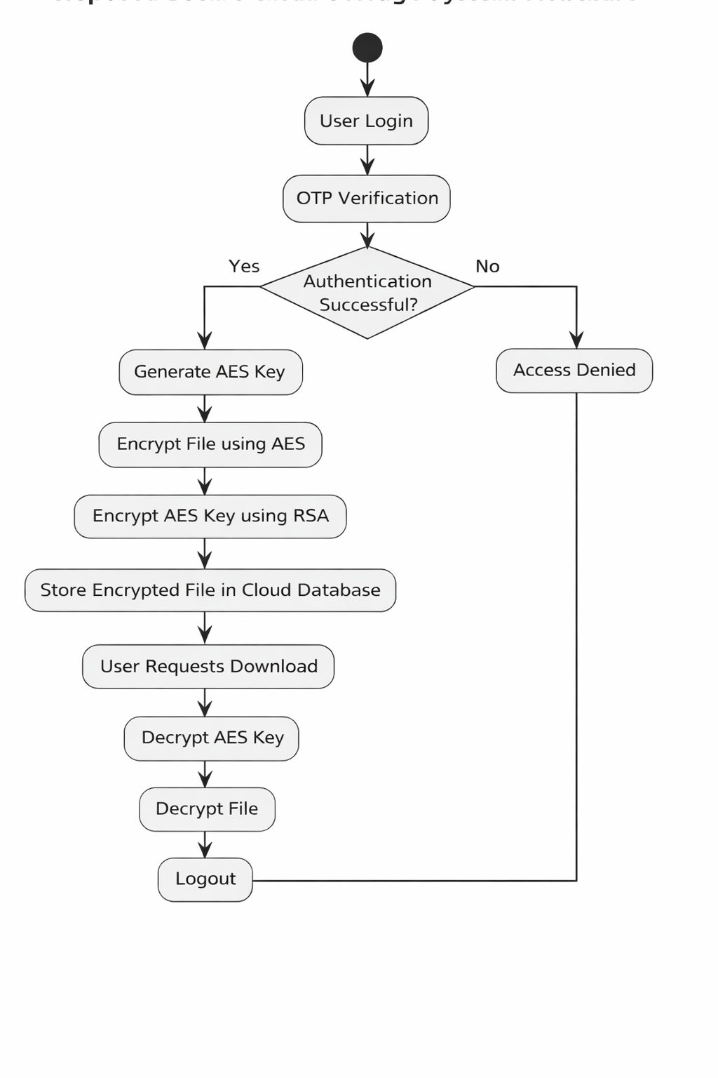
Figure 3.8: Flowchart Diagram

